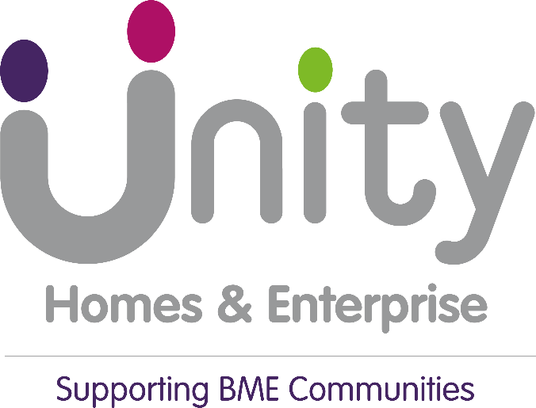

In accordance with the Housing Ombudsman’s Complaint Handling Code, Unity Housing’s Board has considered the following documents:

- Unity’s Housing Ombudsman’s Complaint Handling Code 2025 Self-Assessment
- Unity’s Annual Complaints Report 2024/25

In reviewing these documents, the Board are assured that the self-assessment demonstrates that Unity is compliant with the Housing Ombudsman’s Complaint Handling Code.
The Annual Complaints Report 24/25 highlighted some challenges with performance. The board have sought and are receiving assurance around the performance improvements required. The progress of these will continue to be tracked in our tenant scrutiny, operations committee and board meetings.
Our Member Responsible for Complaints (MRC) on the board is fully involved with the complaints performance improvement plan and the ongoing monitoring of it. As are our tenant scrutiny group members, who will continue to assist Unity in how we can further improve the complaints handling process for customers.

